Tire Pressure Monitor System (TPMS) Generic Warning Only with ECE Reg64 TPMS Hard Button Reset – 2017.5 B562E Specific

Functional Description

This STSS is for B562E CGEA 1.3 Low Content program only or equivalent using a dedicated TPMS button to implement ECE Reg64 TPMS reset. B562E if equipped with MFD uses the MFD for the ECE Reg64 TPMS reset function. If the vehicle is not equipped with an MFD then a hard button is used for the ECE Reg64 TPMS reset function. This STSS could be used for other very low content applications with identical function. Also, this STSS only supports generic TPMS warning (Tire Pressure Low) and system faults and does not support TPMS warning and pressure indication by location.

The Tire Pressure Monitoring System (TPMS) employs radio frequency (RF) transmitters in each tire that transmits via RF link the tire pressure status to an RF receiver located in the Body Control Module (BCM). The BCM in turn will interact with the instrument cluster via HS_CAN providing the operator with tire pressure, system/sensor faults, and tire train mode (service only) information. The instrument cluster will include a yellow telltale (See Telltale Section), message center, and chime generated tones to convey tire pressure warning conditions, system faults, and train mode information to the customer/service technician. The telltale is regulated by NHTSA, and must meet their requirements. The regulated telltale will be controlled by the BCM using unique bits in a dedicated telltale signal within the TPMS message.

The Tire Pressure Monitor System correlates the following signals:
- Tire_Press_System_Stat Signal
- Tire_Press_Telltale Signal (See Tire Pressure Monitor System (TPMS) Telltale section).
- TirePReset_B_Req
- TirePReset_D_Stat
- Operational Mode

ECE Reset Feature:
Per ECE Reg 64 the TPMS system shall need to be resettable by the operator in order for the TPMS to store accurate tire pressure reference points. The intent is to detect very small deviations in placard pressure in order to assist the driver in operating at optimal tire pressure to improve fuel efficiency and lower carbon emissions. The vehicle operator shall be able to reset the TPMS via the instrument cluster. This feature shall only be active in countries which require compliance to ECE Reg 64.

Interfaces

Interface Context Diagram (I/O Block Diagram)
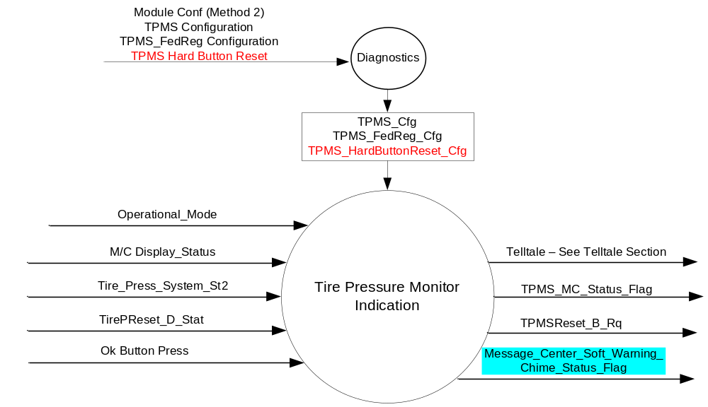

Inputs

      - Internal: Reference section 1.3.1 Operational Modes
      - Internal: M/C Status
      - Mux Signals on the CAN Bus from the Body Control Module (BCM)

- Tire_Press_System_St2 Signal
Signal | Size  (bits) | Detail | Units | Res. | Offset | State  Encoded | Min. | Max.
Tire_Press_  System_Stat | 4 |  | SED | 1 | 0 |  | 0  (0x0) | 15  (0xF)
 |  | Unknown_Composite_Stat |  |  |  | 0x0
 |  | Systm_Fault_Composite_Stat |  |  |  | 0x1
 |  | Sensr_Fault_Composite_Stat |  |  |  | 0x2
 |  | Low_Composite_Stat |  |  |  | 0x3
 |  | Systm_Activ_Composite_Stat |  |  |  | 0x4
 |  | Train_LeftFront_tire |  |  |  | 0x5
 |  | Train_RightFront_tire |  |  |  | 0x6
 |  | Train_RightRear_tire |  |  |  | 0x7
 |  | Train_OutsideRtRear_tire |  |  |  | 0x8
 |  | Train_InsideRtRear _tire |  |  |  | 0x9
 |  | Train_LeftRear_tire |  |  |  | 0xA
 |  | Train_OutsideLeftRear_tire |  |  |  | 0xB
 |  | Train_InsideLeftRear_tire |  |  |  | 0xC
 |  | Training_Complete |  |  |  | 0xD
 |  | Tires_not_trained |  |  |  | 0xE

- TirePReset_D_Stat Signal
Signal | Size  (bits) | Detail | Units | Res. | Offset | State  Encoded | Min. | Max.
TirePReset_D_Stat | 1 |  | SED | 1 | 0 |  | 0  (0x0) | 3  (0x3)
 |  | Null |  |  |  | 0x0
 |  | Ack |  |  |  | 0x1
 |  | Nack |  |  |  | 0x2

Outputs
Base Line: TPMS_MC_Status_flag/ Chime / Telltale (See Telltale Section)
High Line: TPMS_MC_Status_flag/ Chime / Telltale (See Telltale Section)
Message_Center_Soft_Warning_Chime_Status_Flag

- Mux Signal on the CAN Bus from IPC to the Body Control Module (BCM)

- TPMSReset_B_Rq
Signal | Size  (bits) | Detail | Units | Res. | Offset | State  Encoded | Min. | Max.
TirePReset_B_Rq | 1 |  | SED | 1 | 0 |  | 0 (0x0) | 1 (0x1)
 |  | Null |  |  |  | 0x0
 |  | Reset |  |  |  | 0x1

Function/Performance

Operational Modes

Mode | Differentiating Vehicle Conditions
Sleep Mode | TPMS_MC_Status_flags = Inactive
Limited Mode | TPMS_MC_Status_flags = Inactive
Normal Mode | TPMS_MC_Status_flags = Inactive/Active
Crank Mode | TPMS_MC_Status_flags = Inactive/Active

The above table references the setting of the Warning flag as per this section. However, the actual warning display operational modes are displayed in the Message Center section of this SPSS.

Voltage Levels

Per Ford SDS requirements IS-0052 & IS-0053

Human-Machine Interfac

Visual

Indicator Graphics / Display Format
Refer to Settings sHMI section of this SPSS. Settings → Driver Assist → TPMS Reset Funciton

Indicator Color Coordinates

Reference section COLOR & ILLUMINATION REQUIREMENTS (GRAPHICS)

Audio

Message_Center_Soft_Warning_Chime_Status_Flag is associated with all warning messages within this STSS. No audible chime is associated with the Tire Pressure Reset Function within this STSS (see figure 1).

Switch Control Logic

Consumer access to the Tire Pressure Monitoring System Function shall be as specified in the Message Center basic functionality Display.

System Accuracy

TPMS information shall reflect signal state within 100mS.

Operation: Performance and Functional

Subsystem Algorithm Flowchart / State Diagram / State Table

- State Matrix for TPMS Function (M/C)
Operational_Mode | TPMS_Cfg | Tire_Press_  System_Stat | Unknown_Composite  _Stat_Status_Flag | Systm_Fault_Composite  _Stat_Status_Flag | Sensr_Fault_Composite  _Stat_Status_Flag | Low_Composite_Stat  _Status_Flag | Train_LeftFront_tire  _Status_Flag | Train_RightFront_tire  _Status_Flag | Train_RightRear_tire  _Status_Flag | Train_OutsideRtRear  _tire_Status_Flag | Train_InsideRtRear_tire  _Status_Flag | Train_LeftRear_tire  _Status_Flag | Train_OutsideLeftRear  _tire_Status_Flag | Train_InsideLeftRear  _tire_Status_Flag | Training_Complete  _Status_Flag | Tires_not_trained  _Status_Flag
Normal | Enabled | Unknown_  Composite_Stat (0x0) | Active | Inactive | Inactive | Inactive | Inactive | Inactive | Inactive | Inactive | Inactive | Inactive | Inactive | Inactive | Inactive | Inactive
Normal | Enabled | Systm_Fault_  Composite_Stat (0x1) | Inactive | Active | Inactive | Inactive | Inactive | Inactive | Inactive | Inactive | Inactive | Inactive | Inactive | Inactive | Inactive | Inactive
Normal | Enabled | Sensr_Fault_  Composite_Stat (0x2) | Inactive | Inactive | Active | Inactive | Inactive | Inactive | Inactive | Inactive | Inactive | Inactive | Inactive | Inactive | Inactive | Inactive
Normal | Enabled | Low_Composite_Stat (0x3) | Inactive | Inactive | Inactive | Active | Inactive | Inactive | Inactive | Inactive | Inactive | Inactive | Inactive | Inactive | Inactive | Inactive
Normal | Enabled | Systm_Activ_  Composite_Stat (0x4) | Inactive | Inactive | Inactive | Inactive | Inactive | Inactive | Inactive | Inactive | Inactive | Inactive | Inactive | Inactive | Inactive | Inactive
Normal | Enabled | Train_LeftFront_tire (0x5) | Inactive | Inactive | Inactive | Inactive | Active | Inactive | Inactive | Inactive | Inactive | Inactive | Inactive | Inactive | Inactive | Inactive
Normal | Enabled | Train_RightFront_tire (0x6) | Inactive | Inactive | Inactive | Inactive | Inactive | Active | Inactive | Inactive | Inactive | Inactive | Inactive | Inactive | Inactive | Inactive
Normal | Enabled | Train_RightRear_tire (0x7) | Inactive | Inactive | Inactive | Inactive | Inactive | Inactive | Active | Inactive | Inactive | Inactive | Inactive | Inactive | Inactive | Inactive
Normal | Enabled | Train_OutsideRtRear_tire (0x8) | Inactive | Inactive | Inactive | Inactive | Inactive | Inactive | Inactive | Active | Inactive | Inactive | Inactive | Inactive | Inactive | Inactive
Normal | Enabled | Train_InsideRt  Rear _tire (0x9) | Inactive | Inactive | Inactive | Inactive | Inactive | Inactive | Inactive | Inactive | Active | Inactive | Inactive | Inactive | Inactive | Inactive
Normal | Enabled | Train_LeftRear  _tire (0xA) | Inactive | Inactive | Inactive | Inactive | Inactive | Inactive | Inactive | Inactive | Inactive | Active | Inactive | Inactive | Inactive | Inactive
Normal | Enabled | Train_Outside  LeftRear_tire (0xB) | Inactive | Inactive | Inactive | Inactive | Inactive | Inactive | Inactive | Inactive | Inactive | Inactive | Active | Inactive | Inactive | Inactive
Normal | Enabled | Train_InsideLeftRear_tire (0xC) | Inactive | Inactive | Inactive | Inactive | Inactive | Inactive | Inactive | Inactive | Inactive | Inactive | Inactive | Active | Inactive | Inactive
Normal | Enabled | Training_  Complete (0xD) | Inactive | Inactive | Inactive | Inactive | Inactive | Inactive | Inactive | Inactive | Inactive | Inactive | Inactive | Inactive | Active | Inactive
Normal | Enabled | Tires_not_  trained (0xE) | Inactive | Inactive | Inactive | Inactive | Inactive | Inactive | Inactive | Inactive | Inactive | Inactive | Inactive | Inactive | Inactive | Active
Normal | Enabled | Missing as per 1.4.1 | Inactive | Active | Inactive | Inactive | Inactive | Inactive | Inactive | Inactive | Inactive | Inactive | Inactive | Inactive | Inactive | Inactive
All Other Cases |  |  | Inactive

- TPMS Status Flag to Message Center Warning ID and Chime_Status_Flag
Description of Warning | Active MC_Status_Flag | Mc Warning Message ID | Active Chime_Status_Flag
No new TPMS warning displayed. | Unknown_Composite_Stat_Status_Flag | Hold same state. | N/A
Tire Pressure Monitor Fault | Systm_Fault_Composite_Stat_Status_Flag | W440 | Message_Center_Soft_Warning_  Chime_Status_Flag
Tire Pressure Sensor Fault | Sensr_Fault_Composite_Stat_Status_Flag | W360 | Message_Center_Soft_Warning_  Chime_Status_Flag
Low Tire Pressure | Low_Composite_Stat_Status_Flag | W380 | Message_Center_Soft_Warning_  Chime_Status_Flag
Train Left Front Tire | Train_LeftFront_tire_Status_Flag | W405 | Message_Center_Soft_Warning_  Chime_Status_Flag
Train Right Front Tire | Train_RightFront_tire_Status_Flag | W410 | Message_Center_Soft_Warning_  Chime_Status_Flag
Train Right Rear Tire | Train_RightRear_tire_Status_Flag | W415 | Message_Center_Soft_Warning_  Chime_Status_Flag
Train Outside Right Rear Tire | Train_OutsideRtRear_tire_Status_Flag | W417 | Message_Center_Soft_Warning_  Chime_Status_Flag
Train Inside Right Rear Tire | Train_InsideRtRear _tire_Status_Flag | W418 | Message_Center_Soft_Warning_  Chime_Status_Flag
Train Left Rear Tire | Train_LeftRear_tire_Status_Flag | W420 | Message_Center_Soft_Warning_  Chime_Status_Flag
Train Outside Left Rear Tire | Train_OutsideLeftRear_tire_Status_Flag | W422 | Message_Center_Soft_Warning_  Chime_Status_Flag
Train Inside Left Rear Tire | Train_InsideLeftRear_tire_Status_Flag | W423 | Message_Center_Soft_Warning_  Chime_Status_Flag
Training Complete | Training_Complete_Status_Flag | W430 | Message_Center_Soft_Warning_  Chime_Status_Flag
Tires Not Trained- Repeat | Tires_not_trained_Status_Flag | W435 | Message_Center_Soft_Warning_  Chime_Status_Flag

Figure 1: ECE Reg64 TPMS Reset Function Using TPMS Hard Button
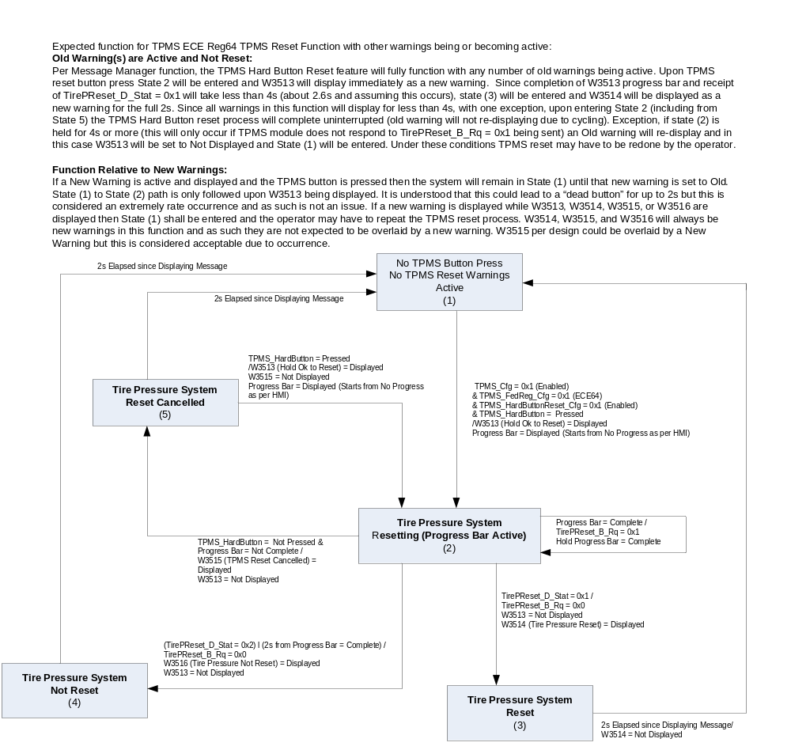

Operation Description (supports algorithm flowchart / state diagram)

- Unknown_Composite_Stat (0x0) is an unused state in signal Tire_Press_System_Stat. Upon receipt
of Unknown_Composite_Stat (0x0) cluster shall remain in state as per last valid signal state received. No DTCs are to be logged upon receipt of unused signal data. Upon receipt of valid signal state TPMS information shall reflect signal state within 100mS
- System Check: If an active TPMS warning exists that warning shall be displayed in system check as per the message center system check description. If no TPMS warning is active there shall be no reference to the TPMS system in system check

Function Safety Classification (EMC)

Class B

Memory Storage

Parameter Name | Description | Value at  Battery Connect | Value at  Module Wake-up
Tire_Press_System_Stat | Can Signal Sent from BCM | 0 (0x0) | 0 (0x0)
TirePReset_D_Stat | Can Signal Sent from BCM | 0 (0x0) | 0 (0x0)
TirePReset_B_Rq | Can Signal Sent from BCM | 0 (0x0) | 0 (0x0)
Unknown_Composite_Stat_Status_Flag | State variable used by M/C Warning Arbitrator | Inactive | Inactive
Systm_Fault_Composite_Stat_Status_Flag | State variable used by M/C Warning Arbitrator | Inactive | Inactive
Sensr_Fault_Composite_Stat_Status_Flag | State variable used by M/C Warning Arbitrator | Inactive | Inactive
Low_Composite_Stat_Status_Flag | State variable used by M/C Warning Arbitrator | Inactive | Inactive
Train_LeftFront_tire_Status_Flag | State variable used by M/C Warning Arbitrator | Inactive | Inactive
Train_RightFront_tire_Status_Flag | State variable used by M/C Warning Arbitrator | Inactive | Inactive
Train_RightRear_tire_Status_Flag | State variable used by M/C Warning Arbitrator | Inactive | Inactive
Train_OutsideRtRear_tire_Status_Flag | State variable used by M/C Warning Arbitrator | Inactive | Inactive
Train_InsideRtRear _tire_Status_Flag | State variable used by M/C Warning Arbitrator | Inactive | Inactive
Train_LeftRear_tire_Status_Flag | State variable used by M/C Warning Arbitrator | Inactive | Inactive
Train_OutsideLeftRear_tire_Status_Flag | State variable used by M/C Warning Arbitrator | Inactive | Inactive
Train_InsideLeftRear_tire_Status_Flag | State variable used by M/C Warning Arbitrator | Inactive | Inactive
Training_Complete_Status_Flag | State variable used by M/C Warning Arbitrator | Inactive | Inactive
Tires_not_trained_Status_Flag | State variable used by M/C Warning Arbitrator | Inactive | Inactive
TPMS_Cfg | State indication for feature presence (EOL configuration) | Use Stored Value | Use Stored Value
TPMS_FedReg_Cfg | State indication to identify FMVSS138 or ECEreg64 functionality (EOL configuration) | Use Stored Value | Use Stored Value
TPMS_HardButtonReset_Cfg | State indication to identify whether TPMS ECEReg64 Reset Hard Button is present. (EOL configuration) | Use Stored Value | Use Stored Value
Operational_Mode | 4 state indicator for cluster operational mode | Limited | Limited or Normal or Crank
Message_Center_Soft_Warning_  Chime_Status_Flag | Used to control the state of the chime to the Chime Arbitrator | Inactive | Inactive

Prove Out

Message Center & Chime: None
Telltale: See TPMS telltale module.

Reconfigurable Telltale

No

Message Center Msg

See Message Center Function

Error Handling

Missing Message Strategy

Error handling for HS-CAN message is specified in the TPMS Telltale Section of this SPSS.
No additional DTCs are specified for the TPMS Warnings.

Diagnostics

Self Test

None

Engineering Test Mode

Reference section “Dealer / Engineering Test Mode (ETM)”

Part II Performance

Supported Diagnostic Trouble Codes (DTCs)
DTC | Description | When Logged
None

DID DExx
Block  Num | Block Description | Size (bits) | Byte(s) | Bits | State: Description | "0" | "1" | Default | Comments/  Information
PACKETED BLOCKS
$00 | Option Content (B&A) | 1 | * | * | TPMS Configuration | Disabled | Enabled | Enabled | Not Dealer Configurable
 |  | 1 |  |  | TPMS FedReg Config | FMVSS138 | ECE64 | FMVSS138 | Not Dealer Configurable
 |  | 1 | * | * | TPMS Hard Button Reset | Disabled | Enabled |  | Used for Low Content applications only.
Note: TPMS FedReg Config is set to 0x0 for U.S., Canada, Mexico and all other countries which do not need to meet ECE reg64. For all countries required to meet ECE reg 64 TPMS FedReg Config shall be set to 0x1.

Reference Specification

FS-5L1T-1560-A5.doc
TPMS Warn TF-0003
TPMS Warn TY-0004

Revision History

STSS Module Revision History
Revision  Level | Name | Change Description | Date
1.0 | J.Blatchford | Initial Release.  This STSS is for B562E CGEA 1.3 Low Content program only or equivalent using a dedicated TPMS button to implement ECE Reg64 TPMS reset. B562E if equipped with MFD uses the MFD for the ECE Reg64 TPMS reset function. If the vehicle is not equipped with an MFD then a hard button is used for the ECE Reg64 TPMS reset function. This STSS could be used for other very low content applications with identical function.  Also, this STSS only supports generic TPMS warning (Tire Pressure Low) and system faults and does not support TPMS warning and pressure indication by location. | 2/6/15
1.1 | ilopezla | This updated adds the Chime_Status_Flags associated with this warning as per Global_Msg_List_ver32_Released_6_24_2015 (all changes are highlighted in light blue)  Section 1.2.1 Aded Message_Center_Soft_Warning_Chime_Status_Flag  Section 1.2.3 Added-  Message_Center_Soft_Warning_Chime_Status_Flag  Section 1.3.5 Updated Table 1.4 –  Changed Table’s Name from “TPMS Status Flag to Message Center Warning ID” To “TPMS Status Flag to Message Center Warning ID and Chime_Status_Flag and Chime_Status_Flag”  Added new column: Active Chime_Status_Flag and its rows  Added Message_Center_Soft_Warning_Chime_Status_Flag  Section 1.3.5.4 Added-  Message_Center_Soft_Warning_Chime_Status_Flag to Memory Storage Table. | 1/12/2016

